Learning Project-II Report
On
“Data Analysis of RX Sales In Industries Using POWER BI Tool”

Submitted in partial fulfillment of
The requirements for the 4th Semester Sessional Examination of
BACHELOR OF TECHNOLOGY
IN
COMPUTER SCIENCE & ENGINEERING
By
NAME:-
Piyush Kumar (20CSE038)
Akshat Kumar Singh(20CSE022)
Priya Khetan (20CSE052)
Registration No:-
20UG010171
20UG010155
20UG010184

DEPARTMENT OF COMPUTER SCIENCE & ENGINEERING


GIET UNIVERSITY, Gunupur
2021 - 22
GIET UNIVERSITY,GUNUPUR
Dist. - Rayagada, Odisha-765022, Contact:- +91 7735745535, 06857-250170,172, Visit us:- www.giet.edu

Department of Computer Science & Engineering

CERTIFICATE
This is to certify that the project work entitled “Data Analysis of RX Sales In Industries Using POWER BI Tool” is done by Name- piyush Kumar(20CSE038) , Akshat Kumar Singh(20CSE022) and Priya Khetan(20CSE052) ,
Regd. No.- 20UG010171,20UG010155 and 20UG010184 in partial fulfillment of the requirements for the 4th Semester Sessional Examination of Bachelor of Technology in Computer Science and Engineering during the academic year 2021-22. This work is submitted to the department as a part of evaluation of 4th Semester Learning Project-II
Name:-Piyush Kumar ,Akshat Kumar singh and Priya Khetan
Class Teacher :- Priyanka Priyadarshani

Project Cordinator:-Mr. Bhavani Sankar Panda
Project Coordinator, 3rd Year HoD, CSE

ACKNOWLEDGEMENT

I would like to thank my class teacher Ms. Priyanka Priyadarshini for supporting and guiding us in project.

Secondly I would like to thanks our Project Coordinator Mr. Bhavani Sankar Panda for giving us opportunity to do so.

A special gratitude to our HOD Dr. Sanjay Kumar Kuanar for his constant support and guidance.

Thanks to all my team mates for their cooperation.

Piyush Kumar(20UG010171)
Akshat Kumar singh(20UG010155)
Priya Khetan(20UG010184)

Data Analysis of RX Sales In Industries
Using POWER BI Tool

- OBJECTIVE:-

The main aim of Data Analysis is to:-
- Apply statistical analysis of data and technologies on data to find trends and solve problem.
- It makes studying data a lot simpler and more accurate.
- It helps the researchers to interpret the data.
- It is used to find meaning in data so that the derived knowledge can be used to make informed decisions.
- Assessment and improvement of the quality of the data.
- It helps to analyse data from different outlooks.
- SCOPE:-
Data analysis is used everywhere because of its
- Numerous benefits
- High demand
- Automate the decision making process.
It’s scope is limitless.
- WAYS TO USE DATA ANALYSIS:-

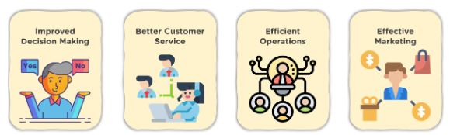

1-IMPROVED DECISION MAKING:-
Data Analytics eliminates guesswork and manual tasks. Be it choosing the right content, planning marketing campaigns, or developing products. Organizations can use the insights they gain from data analytics to make informed decisions. Thus, leading to better outcomes and customer satisfaction.
2-Better Customer Service:-
Data analytics allows you to tailor customer service according to their needs. It also provides personalization and builds stronger relationships with customers. Analyzed data can reveal information about customers’ interests, concerns, and more. It helps you give better recommendations for products and services.

3-Efficient Operations:-
With the help of data analytics, you can streamline your processes, save money, and boost production. With an improved understanding of what your audience wants, you spend lesser time creating ads and content that aren’t in line with your audience’s interests.
4-Effective Marketing:-
Data analytics gives you valuable insights into how your campaigns are performing. This helps in fine-tuning them for optimal outcomes. Additionally, you can also find potential customers who are most likely to interact with a campaign and convert into leads.

- STEPS INVOLVED IN DATA ANALYTICS:-
There are five steps involved in data analytics :-
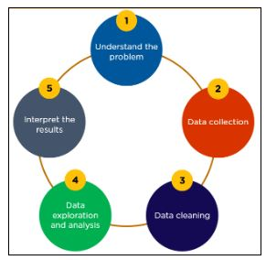
- Understand the problem:-
Understanding the business problems, defining the organizational goals, and planning a lucrative solution is the first step in the analytics process. E-commerce companies often encounter issues such as predicting the return of items, giving relevant product recommendations, cancellation of orders, identifying frauds, optimizing vehicle routing, etc.
- Data collection:-
We need to collect transactional business data and customer-related information from the past few years to address the problems your business is facing. The data can have information about the total units that were sold for a product, the sales, and profit that were made, and also when was the order placed. Past data plays a crucial role in shaping the future of a business.
- Data Cleaning:-
Now, all the data you collect will often be disorderly, messy, and contain unwanted missing values. Such data is not suitable or relevant for performing data analysis. Hence, you need to clean the data to remove unwanted, redundant, and missing values to make it ready for analysis.
- Data Exploration and Analysis:-
After you gather the right data, the next vital step is to execute exploratory data analysis. You can use data visualization and business intelligence tools, data mining techniques, and predictive modeling to analyze, visualize, and predict future outcomes from this data. Applying these methods can tell you the impact and relationship of a certain feature as compared to other variables.
- Interpret the Result:-
The final step is to interpret the results and validate if the outcomes meet your expectations. You can find out hidden patterns and future trends. This will help you gain insights that will support you with appropriate data-driven decision making.

- DATA ANALYTICS TOOL:-
There are various types of Analytics tool:-
1- Python: Python is an object-oriented open-source programming language. It supports a range of libraries for data manipulation, data visualization, and data modeling.
2-R: R is an open-source programming language majorly used for numerical and statistical analysis. It provides a range of libraries for data analysis and visualization.
3-Tableau: It is a simplified data visualization and analytics tool. This helps you create a variety of visualizations to present the data interactively, build reports, and dashboards to showcase insights and trends.
4-Power BI: Power BI is a business intelligence tool that has an easy drag and drop functionality. It supports multiple data sources with features that visually appeal to data. Power BI supports features that help you ask questions to your data and get immediate insights.
5- QlikView: QlikView offers interactive analytics with in-memory storage technology to analyze vast volumes of data and use data discoveries to support decision making. It provides social data discovery and interactive guided analytics. It can manipulate colossal data sets instantly with accuracy.
6-Apache Spark: Apache Spark is an open-source data analytics engine that processes data in real-time and carries out sophisticated analytics using SQL queries and machine learning algorithms.
7-SAS: SAS is a statistical analysis software that can help you perform analytics, visualize data, write SQL queries, perform statistical analysis, and build machine learning models to make future predictions.

BI???

Business intelligence (BI) comprises the strategies and technologies used by enterprises for the data analysis and management of business information.[1] Common functions of business intelligence technologies include reporting, online analytical processing, analytics, dashboard development, data mining, process mining, complex event processing, business performance management, benchmarking, text mining, predictive analytics, and prescriptive analytics.
BI tools can handle large amounts of structured and sometimes unstructured data to help identify, develop, and otherwise create new strategic business opportunities. They aim to allow for the easy interpretation of these big data. Identifying new opportunities and implementing an effective strategy based on insights can provide businesses with a competitive market advantage and long-term stability, and help them take strategic decisions.[2]
Business intelligence can be used by enterprises to support a wide range of business decisions ranging from operational to strategic. Basic operating decisions include product positioning or pricing. Strategic business decisions involve priorities, goals, and directions at the broadest level. In all cases, BI is most effective when it combines data derived from the market in which a company operates (external data) with data from company sources internal to the business such as financial and operations data (internal data). When combined, external and internal data can provide a complete picture which, in effect, creates an "intelligence" that cannot be derived from any singular set of data.[3]
Among myriad uses, business intelligence tools empower organizations to gain insight into new markets, to assess demand and suitability of products and services for different market segments, and to gauge the impact of marketing efforts.[4]
BI applications use data gathered from a data warehouse (DW) or from a data mart, and the concepts of BI and DW combine as "BI/DW"[5] or as "BIDW". A data warehouse contains a copy of analytical data that facilitates decision support.

POWER BI:
Power BI is a collection of software services, apps, and connectors that work together to turn your unrelated sources of data into coherent, visually immersive, and interactive insights. Your data may be an Excel spreadsheet, or a collection of cloud-based and on-premises hybrid data warehouses. Power BI lets you easily connect to your data sources, visualize and discover what's important, and share that with anyone or everyone you want.

The parts of Power BI
Power BI consists of several elements that all work together, starting with these three basics:
- A Windows desktop application called Power BI Desktop.
- An online SaaS (Software as a Service) service called the Power BI service.
- Power BI mobile apps for Windows, iOS, and Android devices.
These three elements—Power BI Desktop, the service, and the mobile apps—are designed to let you create, share, and consume business insights in the way that serves you and your role most effectively.
Beyond those three, Power BI also features two other elements:
- Power BI Report Builder, for creating paginated reports to share in the Power BI service. Read more about paginated reports later in this article.
- Power BI Report Server, an on-premises report server where you can publish your Power BI reports, after creating them in Power BI Desktop. Read more about Power BI Report Server later in this article.

The flow of work in Power BI
One common workflow in Power BI begins by connecting to data sources in Power BI Desktop and building a report. You then publish that report from Power BI Desktop to the Power BI service, and share it so business users in the Power BI service and on mobile devices can view and interact with the report.
This workflow is common, and shows how the three main Power BI elements complement one another.

DASHBOARD

A dashboard is a visual display of all of your data. While it can be used in all kinds of different ways, its primary intention is to provide information at-a-glance, such as KPIs.
A dashboard usually sits on its own page and receives information from a linked database. In many cases it’s configurable, allowing you the ability to choose which data you want to see and whether you want to include charts or graphs to visualize the numbers.

Why Are Dashboards Important?
Dashboards allow all kinds of professionals the ability to monitor performance, create reports and set estimates and targets for future work.
Other benefits include:

.A visual representation of performance, such as with charts and graphs

.The ability to identify trends

.An easy way of measuring efficiency

.The means to generate detailed reports with a single click

.The capacity to make more informed decisions

.Total visibility of all systems, campaigns, and actions

.Quick identification of data outliers and correlations

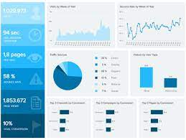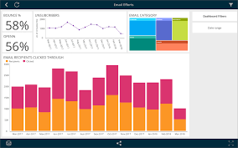
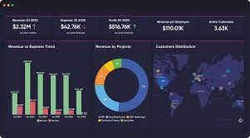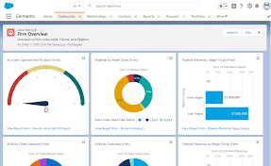

RX SALES
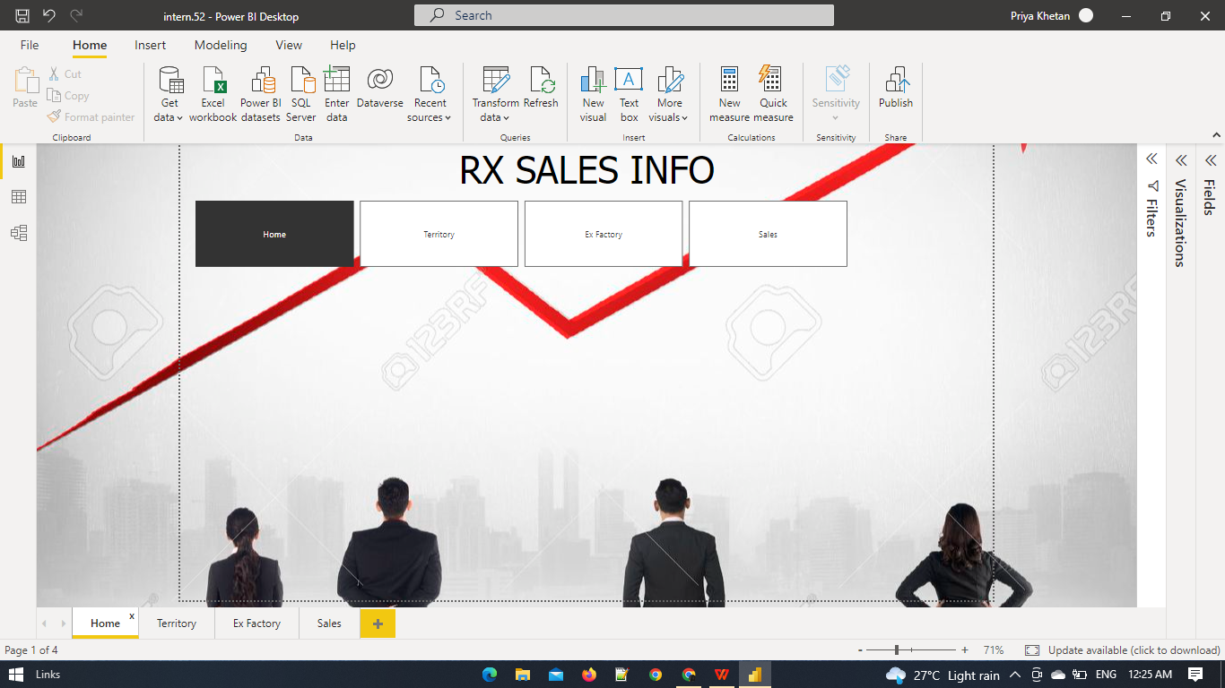
NAVIGATION PAGE:
This is the navigation page where we have linked the different buttons of our dashboard.

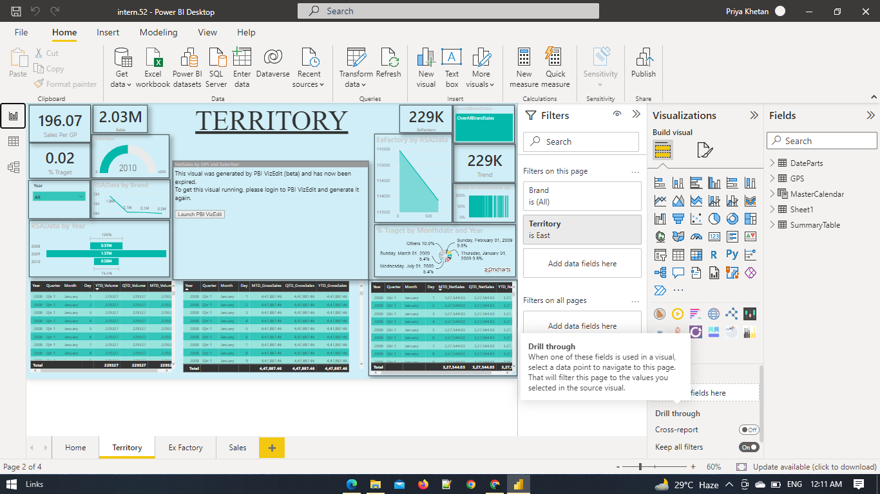
TERRITORY:
This is the territory page where the sales happening on the basis of product and target percentage(year wise and month wise).
We have used card,slicer,clustered column chart and table to analyze data year wise.

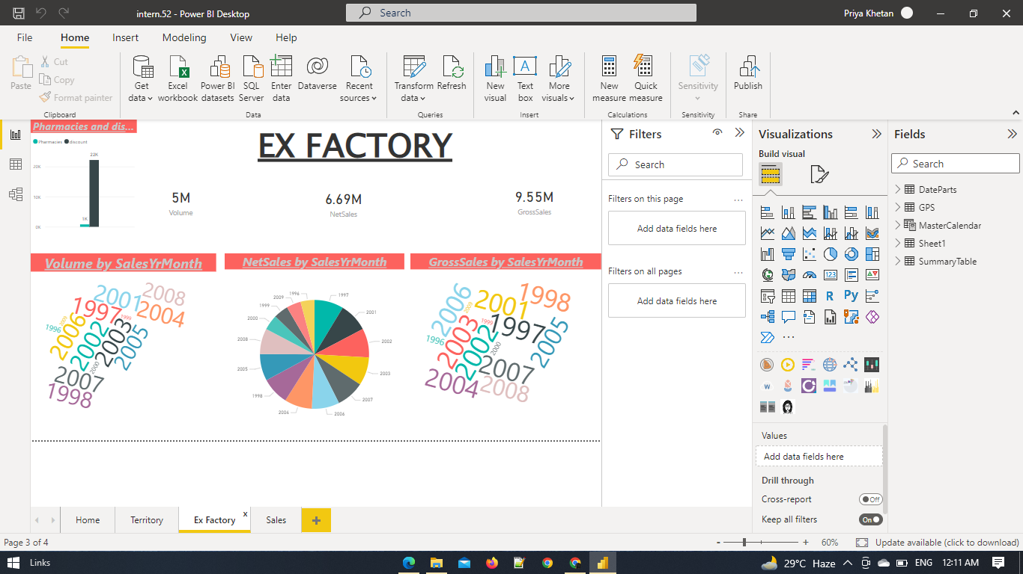
EX FACTORY:
This page represents selling of goods from seller’s factory.
Here, with the help of pi chart,car and bar chart we have shown VOLUME ,NET SALES, and GROSS SALES by SALES PER MONTH.

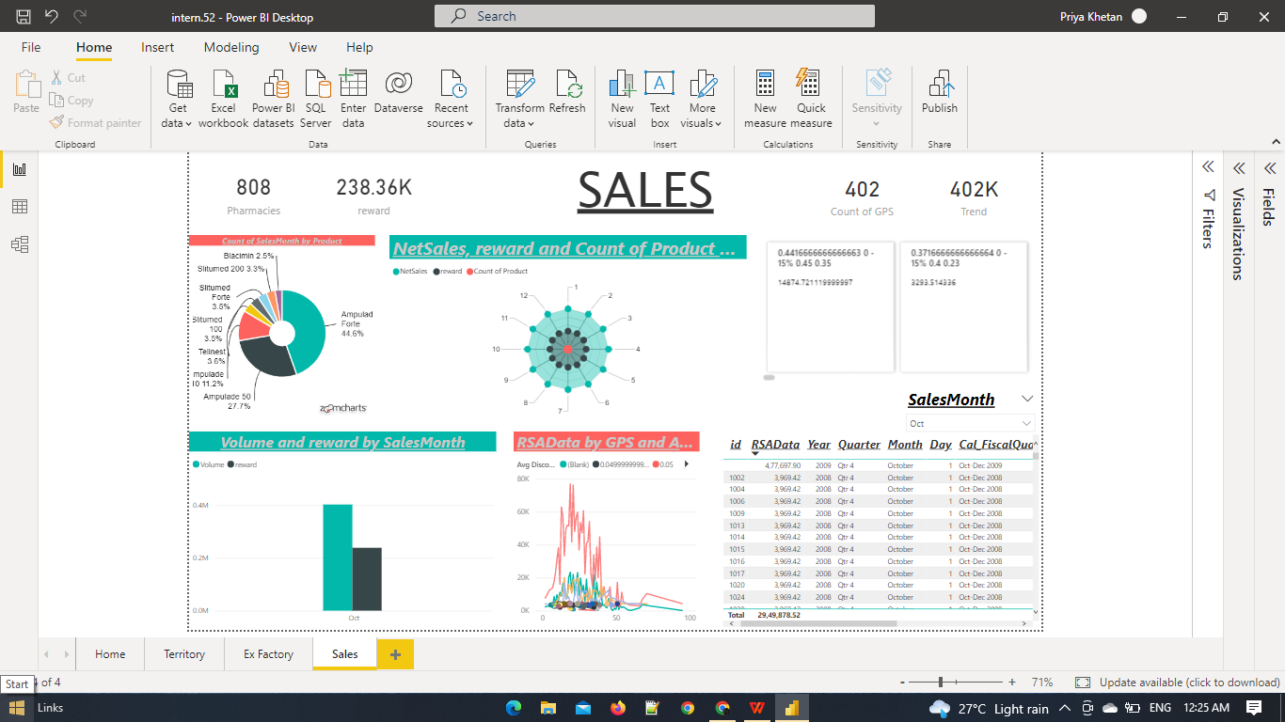
SALES:
Sales Page depicts how sales happen in industries and calculated different measures.

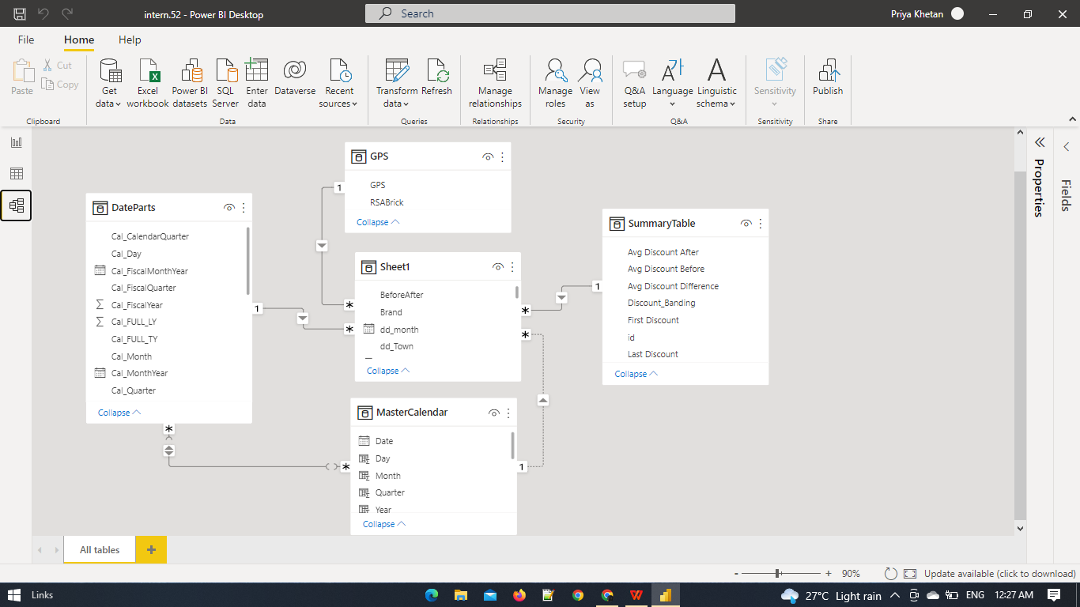
DATA MODEl:
CONCLUSION:
The purpose of this project was to identify the effective stratergies for dealing with Power BI tool inorder to enhance the visualizations for different reports therby making the analysis of data much simpler and easier to understand. When it comes to industrial point of view this helps the companies to predict their sales and analyze accordingly their future plans.
Power BI is one of the very useful tools that can help us to analyze any kind of data model. Also we can customize and create our own dashboard.
This project was a complete hands on experience for our team and the entire work was completed by us .

REFERENCE:
>Lagazon LMS
>Wikipedia

THANK YOU
TEAM-22

